**Problem 4 –**

Running the SerializationTest Class for searializing the objects in two different file –

For file output1.ser

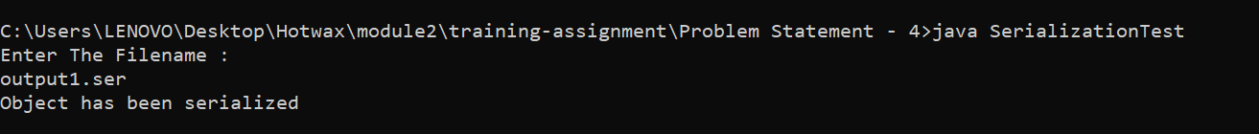

For file output2.ser



Running the DeserializationTest class for reading the serialized files reading both the files ---

In file output1.ser

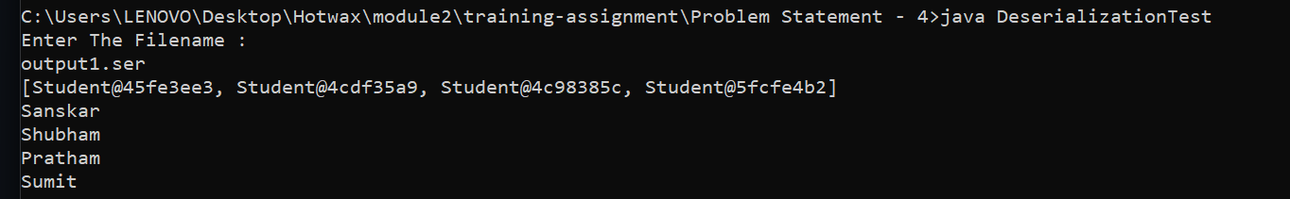

In file output2.ser

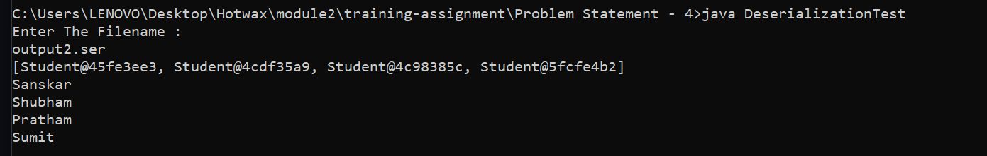

Now after all this changes made accordingly

Change **dateOfBirth** type from java.lang.String to java.util.Date and change the constructor implementation accordingly. Don’t change the signature of the constructor. Just use a single parameter constructor of the Date class to assign the passed String Date to “dateOfBirth”.

Getting Error in both the files while deserializing –

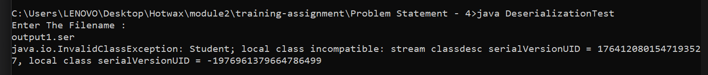



Solution For this –

To explicitly declare and initialize serialVersionUID .

If a class does not explicitly define a private static final long serialVersionUID in the code it will be autogenerated, and there is no guarantee that different machines will generate the same id; it looks like that is exactly what happened. Also if the classes are different in any way (using different versions of the class) the autogenerated serialVersionUIDs will also be different.

Made changes in the class –

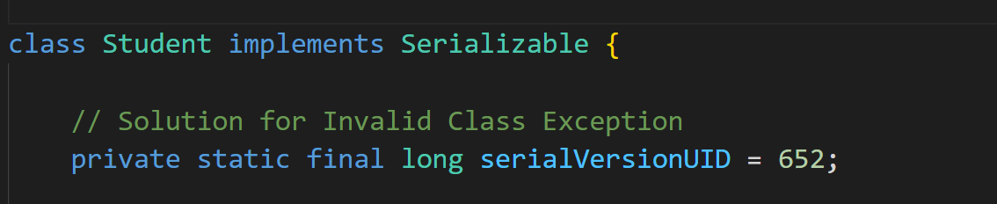

After that i recreated the output1.ser with SerializationTest



Now I made changes to class – date type to string type

And deserialized it with Deserialization Class –

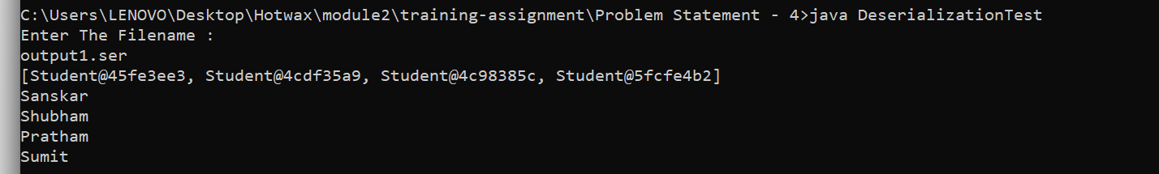

Still able to read it worked.